[Drug designing through computational method]
submitted to DR. RUBAB ZAHRA NAQVI
Tahreem waris
uaf
2026
Network pharmacology for computational Drug designing

Introduction:
Network Pharmacology is a systems biology approach to drug discovery. Unlike traditional drug design, which assumes "one drug → one target → one disease," network pharmacology assumes that a drug can interact with multiple targets, and diseases are controlled by complex biological networks rather than a single gene or protein.
Principle of Network Pharmacology
The main principle is based on the idea that:
Biological systems work as interconnected networks, not isolated molecules.
For example,
- A disease may involve hundreds of genes.
- A drug may affect dozens of proteins.
- Those proteins interact with each other in signaling pathways.
Instead of studying one protein at a time, network pharmacology studies the entire interaction network.
Advantages of Network Pharmacology
- Studies diseases as biological systems instead of isolated targets.
- Identifies multiple therapeutic targets.
- Supports drug repurposing.
- Integrates genomics, proteomics, and metabolomics data.
- Reduces time and cost in early-stage drug discovery.
- Complements molecular docking by prioritizing the most relevant targets.
Objectives of Network Pharmacology:
- Identify disease-related genes and proteins.
- Predict potential drug targets.
- Construct and analyze biological interaction networks.
- Identify hub genes and key signaling pathways.
- Study protein–protein interactions.
- Predict drug–target interactions.
- Support molecular docking and virtual screening.
- Facilitate multi-target drug discovery.
- Reduce the cost and time of drug development.
- Improve understanding of disease mechanisms for better therapeutic design.
Software used
Cytoscape
linkhttps://cytoscape.org/download.html
Database: linkhttps://www.genecards.org/
PPI FILE analysis Linkhttps://string-db.org/cgi/input?sessionId=bXxNqYfcymot&input_page_active_form=multiple_identifiers
PPI network link
https://string-db.org/cgi/network?taskId=bZnzf7id3bP8&sessionId=bDgnEB7OBnhx
DAVID linkhttps://davidbioinformatics.nih.gov/workspace.html
SWISS ADME:https://www.swissadme.ch/index.php
Toxicity through protox 3.0
https://tox.charite.de/protox3/index.php?site=compound_input

Project workflow:
- Disease gene collection (GeneCards)
- Protein-coding gene filtering
- STRING PPI network
- Cytoscape analysis
- Hub gene identification (MCC)
- GO Enrichment Analysis
    - Biological Process (BP)
    - Molecular Function (MF)
    - Cellular Component (CC)
- Kegg pathway analysis
- Select the target protein
- Select the ligand
- ADME screening for the ligand
- Molecular docking
- Interaction analysis
Diseases selection :
Hepatocellular carcinoma (HCC) is the most common type of primary liver cancer and one of the leading causes of cancer-related deaths worldwide. It is associated with chronic liver diseases and remains a major global health challenge, highlighting the need for effective therapeutic targets and novel treatment strategies

Protein coding and gene filtering:
To improve the reliability of the dataset, only protein-coding genes were retained, while non-protein-coding genes, including long non-coding RNAs (lncRNAs), microRNAs (miRNAs), pseudogenes, and other non-coding transcripts, were excluded. The filtered gene list was subsequently used for protein–protein interaction (PPI) network construction, hub gene identification, functional enrichment analysis, and target protein selection for molecular docking studies.
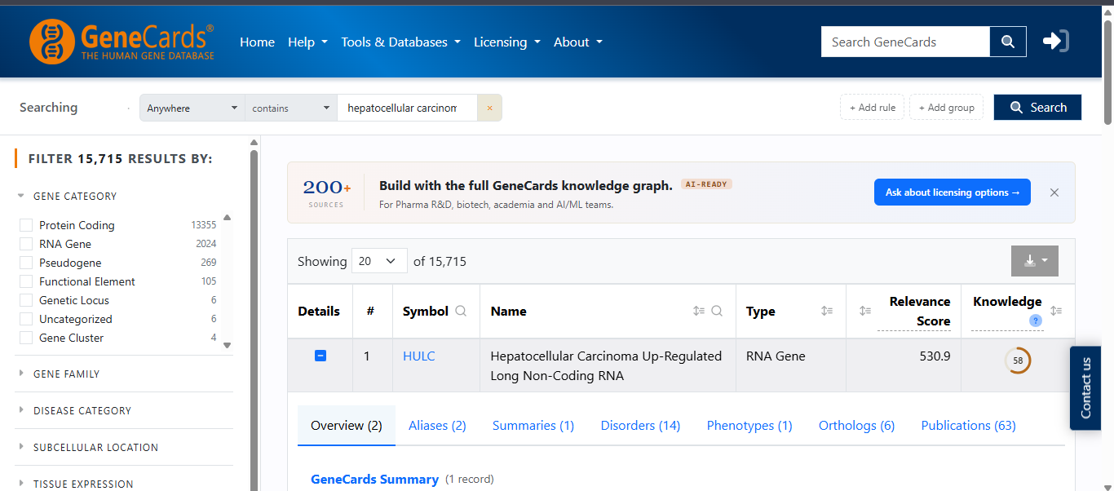
Figure 1 Screenshot of the GeneCards database search interface showing results for the query "hepatocellular carcinoma," yielding 15,715 total entries across gene categories including protein-coding genes, RNA genes, pseudogenes, and functional elements. The top-ranked result, HULC (Hepatocellular Carcinoma Up-Regulated Long Non-Coding RNA), is displayed with a Relevance Score of 530.9 and a Knowledge Score of 58, identifying it as a long non-coding RNA gene strongly associated with hepatocellular carcinoma. This search was used to identify disease-relevant gene/RNA targets associated with hepatocellular carcinoma for further investigation in this study.

String PPI network:
Protein–protein interaction (PPI) analysis was performed using the STRING database (Search Tool for the Retrieval of Interacting Genes/Proteins). The selected genes were uploaded to STRING, and the organism was set to Homo sapiens (taxonomic identifier: 9606). A minimum required interaction score of 0.4 (medium confidence) was applied, and disconnected nodes were hidden to improve network clarity. The resulting interaction network was analyzed to identify functional relationships among proteins.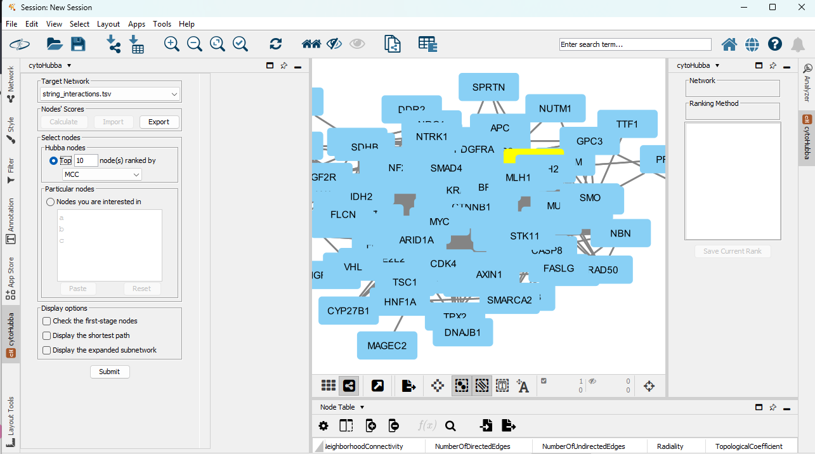
Figure 2 Protein–protein interaction (PPI) network of hepatocellular carcinoma (HCC)-associated genes imported from the STRING database into Cytoscape. The network illustrates the interactions among HCC-related proteins and serves as the basis for topological network analysis. The cytoHubba plugin is shown with the Maximal Clique Centrality (MCC) algorithm selected for subsequent identification and ranking of hub genes.
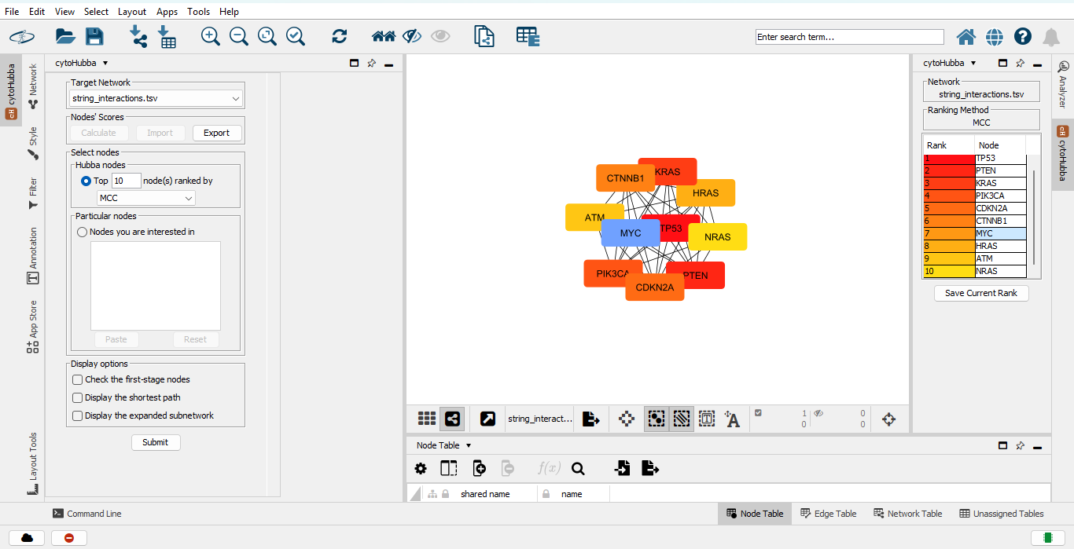
Figure 3 Screenshot of cytoHubba analysis in Cytoscape showing the identification of the top 10 hub genes from the STRING-derived PPI network using the Maximal Clique Centrality (MCC) algorithm. The ranked hub genes were selected for subsequent pathway analysis and molecular docking studies.

Rank | Hub Gene | Importance in HCC
1 | TP53 | Tumor suppressor, most frequently mutated in HCC
2 | PTEN | Tumor suppressor regulating the PI3K/AKT pathway
3 | KRAS | Oncogene involved in cell proliferation
4 | PIK3CA | Activates the PI3K/AKT signaling pathway
5 | CDKN2A | Cell cycle regulator
6 | CTNNB1 | Wnt/β-catenin signaling, commonly mutated in HCC
7 | MYC | Major oncogene promoting tumor growth
8 | HRAS | Ras family oncogene
9 | ATM | DNA damage response protein
10 | NRAS | Ras family oncogene

GO Enrichment Analysis:
Genes rarely function independently; instead, they participate in common biological pathways and cellular processes. After identifying disease-associated or differentially expressed genes, it is essential to determine the biological functions these genes collectively perform
Functional Annotation Chart
The Functional Annotation Chart presents the enrichment results as a table, where each row corresponds to one significantly enriched annotation term (GO, KEGG, InterPro, UniProt keywords, etc.). For GO enrichment analysis, the chart is divided into:
- GOTERM_BP_DIRECT (Biological Process)
- GOTERM_CC_DIRECT (Cellular Component)
- GOTERM_MF_DIRECT (Molecular Function)
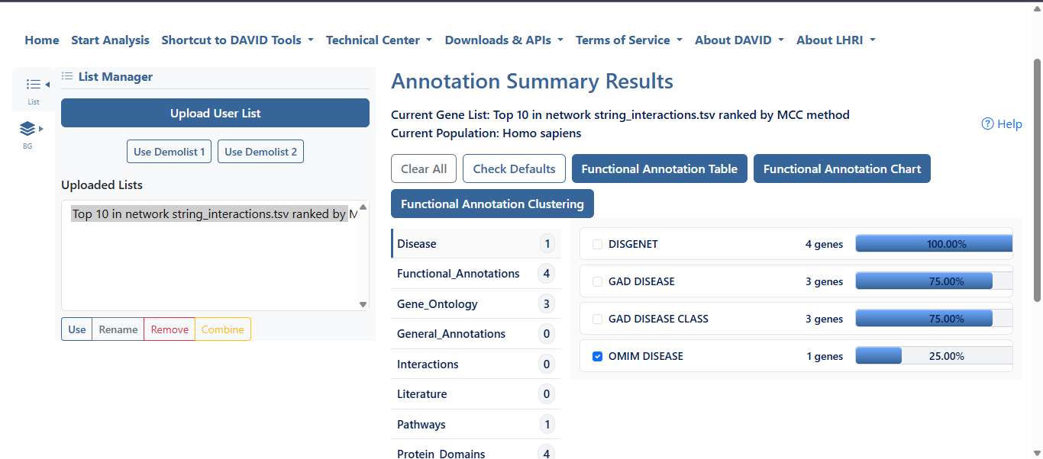
Figure 4 DAVID Annotation Summary Results showing the functional annotation categories of the top 10 hub genes identified from the hepatocellular carcinoma (HCC) protein–protein interaction network. The uploaded gene list was analyzed against the Homo sapiens background, revealing significant disease-related annotations
The uploaded hubb genes on the DAVID are associated with multiple annotation categories, including Disease, Gene Ontology (GO), Functional Annotations, Pathways, and Protein Domains, demonstrating that the selected hub genes participate in diverse biological functions and disease-related processes.
These results confirm that the selected hub genes have strong associations with human diseases, supporting their biological relevance in hepatocellular carcinoma and justifying their use for subsequent Gene Ontology (GO), KEGG pathway enrichment, and molecular docking analyses.

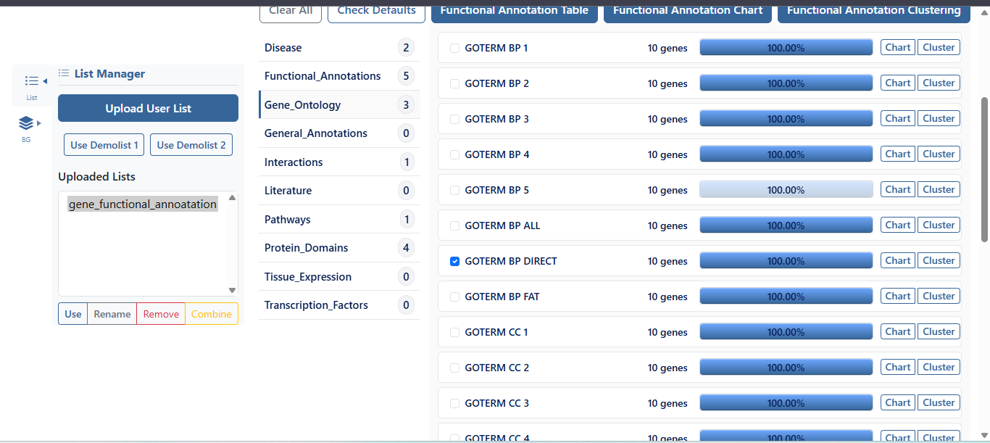
Figure 5 The Functional Annotation Chart presents the enrichment results as a table, where each row corresponds to one significantly enriched annotation term (GO, KEGG, InterPro, UniProt keywords, etc.). For GO enrichment analysis, the chart is divided into: GOTERM_BP_DIRECT (Biological Process), GOTERM_CC_DIRECT (Cellular Component), GOTERM_MF_DIRECT (Molecular Function)
Kegg pathway:
Examining each gene individually, KEGG evaluates whether a group of genes is overrepresented in known biological pathways compared to what would be expected by chance.In the context of hepatocellular carcinoma (HCC), KEGG enrichment analysis identifies the signaling pathways that contribute to liver cancer initiation, progression, metastasis, angiogenesis, and resistance to therapy. This provides a systems-level understanding of disease mechanisms and helps identify potential therapeutic target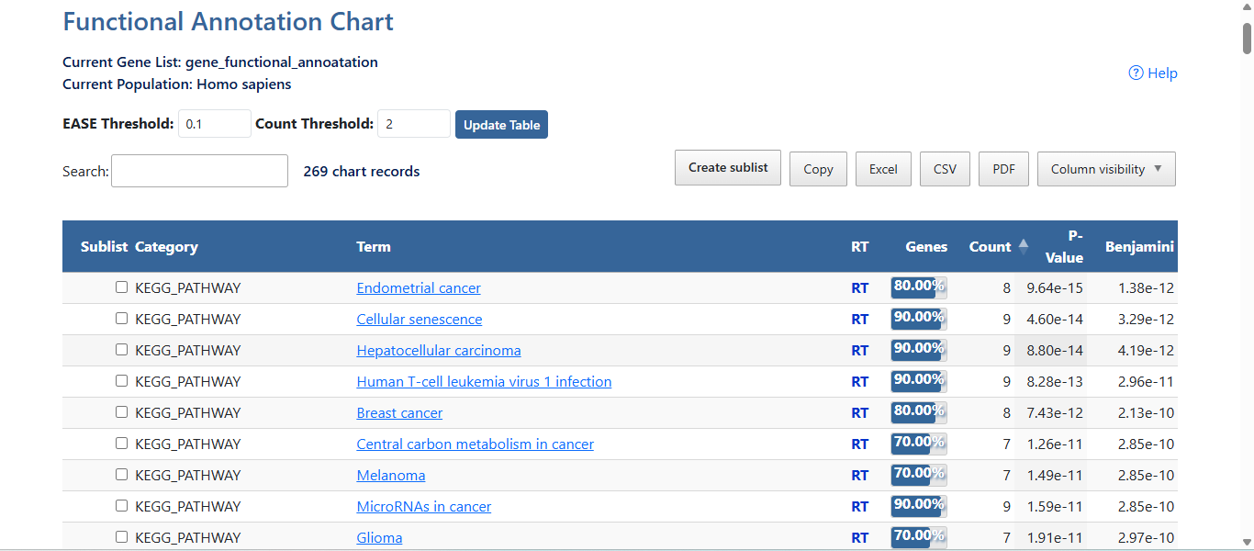
Figure 6 The functional annotation chart from the DAVID shows the KEGG pathway of hepatocellular carcinoma. 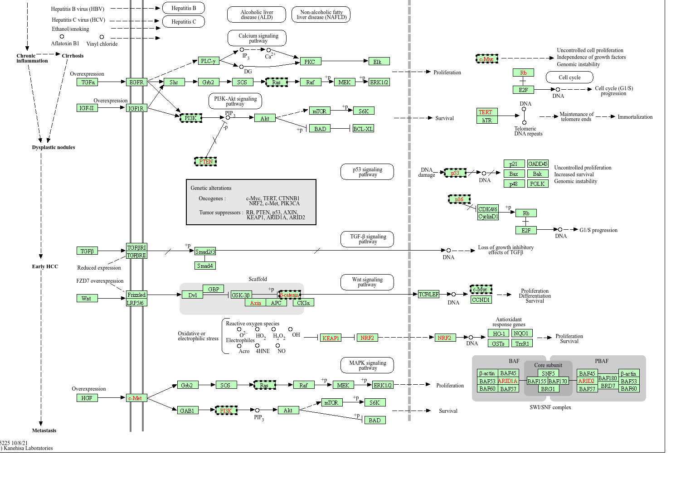Figure 7 KEGG pathway map of hepatocellular carcinoma (HCC) showing key signaling cascades (EGFR/IGF1R–PI3K–Akt–mTOR, RAS–MAPK, Wnt/β-catenin, TGF-β, p53) driving HCC progression from cirrhosis to metastasis, with oncogenes and tumor suppressors highlighting potential druggable targets. Adapted from the KEGG Pathway Database (Kanehisa Laboratories)

Protein selection:
Based on protein–protein interaction (PPI) network analysis and hub gene identification using the Maximum Clique Centrality (MCC) algorithm in Cytoscape, and the KEGG pathway analysis PIK3CA (Phosphatidylinositol-4,5-bisphosphate 3-kinase catalytic subunit alpha) was selected as the target protein for molecular docking. PIK3CA is a key oncogene involved in the PI3K/Akt signaling pathway, which regulates essential cellular processes including cell proliferation, survival, growth, metabolism, and apoptosis. Aberrant activation or mutation of PIK3CA has been frequently reported in hepatocellular carcinoma (HCC), contributing to tumor initiation, progression, angiogenesis, and resistance to therapy. KEGG pathway enrichment analysis further demonstrated that PIK3CA is significantly associated with the hepatocellular carcinoma pathway, highlighting its biological relevance in HCC pathogenesis. Therefore, PIK3CA was selected as the therapeutic target for this study.
PROTEIN RETRIVAL: The three-dimensional crystal structure of human PIK3CA was retrieved from the Protein Data Bank (PDB ID: 4JPS Resolution: 2.20 Å) because it provides a high-quality experimentally determined structure suitable for molecular

docking studies and contains a well-characterized active site for evaluating the binding interactions of selected phytochemicals.
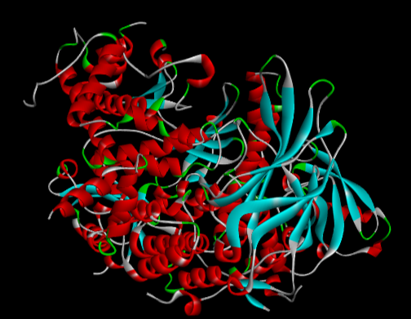
Figure 8 Cartoon representation of the crystal structure of PI3Kα (PDB ID: 4JPS), showing the catalytic subunit (p110α) in complex with the p85α regulatory subunit, co-crystallized with an isoform-selective inhibitor. α-helices are shown in red, β-strands in cyan, and loop regions in green/white, illustrating the mixed α/β fold of the kinase domain relevant to structure-based drug design against PI3Kα.
Ligand selection:
In structure-based drug design, ligands are selected because they have the potential to interact specifically with the target protein and modulate its biological function. The selection of appropriate ligands is based on their reported biological activity, target specificity, favorable binding affinity, drug-likeness, pharmacokinetic properties, and safety profile. During molecular docking, the ligand binds to the active site of the target protein through hydrogen bonds, hydrophobic interactions, and other non-covalent forces, allowing researchers to predict its binding mode and inhibitory potential. Therefore, careful ligand selection is a critical step in identifying promising lead compounds for further drug development the shortlisted ligands to dock with the 4JPS protein are :
compound name | pubchem ID |  | molecular weight
Curcumin | 969516 |  | 368.4 g/mol
Demethoxycurcumin | 5469424 |  | 338.4 g/mol
Bisdemethoxycurcumin | 5315472 |  | 308.3 g/mol
ar_turmerone | 160512 |  | 216.32 g/mol
Beta_turmerone | 196216 |  | 218.33 g/mol
alpha_turmerone | 6434375 |  | 273.37 g/mol
Germacrone | 6436348 |  | 218.33 g/mol
curdione | 14106072 |  | 236.35 g/mol
Cyclocurcumin | 5318992 |  | 728.8 g/mol
calebin A | 637429 |  | 384.4 g/mol

Selection criteria:
A total of ten phytochemicals reported from Curcuma longa were initially considered as potential ligands. All compounds were subjected to ADME profiling using SwissADME and toxicity prediction using ProTox-3 to evaluate their pharmacokinetic properties, drug-likeness, and safety profiles. Based on these analyses, Curcumin, Demethoxycurcumin, and Bisdemethoxycurcumin were selected for molecular docking because they exhibited the most favorable overall characteristics, including compliance with Lipinski's Rule of Five, high gastrointestinal absorption, acceptable bioavailability, satisfactory water solubility, absence of significant PAINS and brenk alerts, favorable synthetic accessibility, and comparatively lower predicted toxicity. Furthermore, these three compounds are the principal curcuminoids responsible for the majority of the biological and anticancer activities of Curcuma longa, with extensive experimental evidence supporting their therapeutic potential against hepatocellular carcinoma and other cancers. Therefore, they were considered the most promising candidates for docking against the selected target protein (PIK3CA), while the remaining phytochemicals were excluded due to comparatively less favorable pharmacokinetic properties, higher predicted toxicity, or limited evidence supporting their anticancer activity.

SWISS results:
For each compound, examine:
- Lipinski's Rule of Five, GI absorption, Bioavailability score, Water solubility, Drug-likeness, PAINS alerts, Brenk alerts, Synthetic accessibility, BOILED-Egg model
Toxicity results:
We will evaluate each selected phytochemical using tools such as Protox-3 (or an equivalent toxicity prediction server) to assess:
- LD₅₀ (acute oral toxicity, Toxicity class, Hepatotoxicity, Carcinogenicity
- Mutagenicity, Immunotoxicity, Cytotoxicity
SWISS ADME Scientific Interpretation and toxicity analysis of ligands:
The ADME ANALYSIS Curcumin:
- Passed Lipinski's Rule of Five, High gastrointestinal absorption., Acceptable bioavailability (0.55),No PAINS alerts, Suitable for molecular docking.
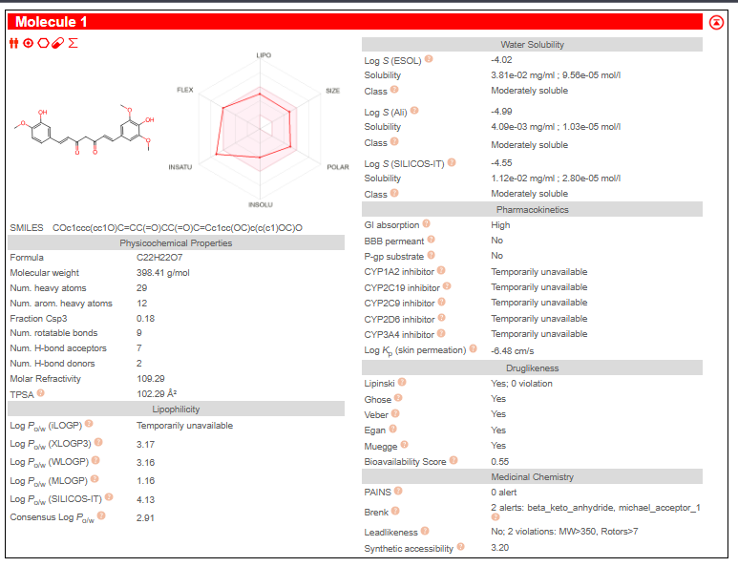
Toxicity analysis:
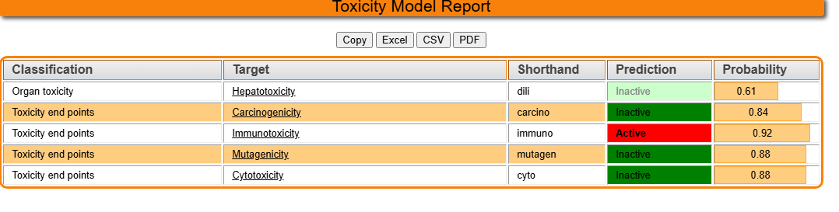Demethoxycurcumin
- Similar to Curcumin, Good oral absorption, Good drug-likeness, Suitable for docking.
THE ADME ANALYSIS: 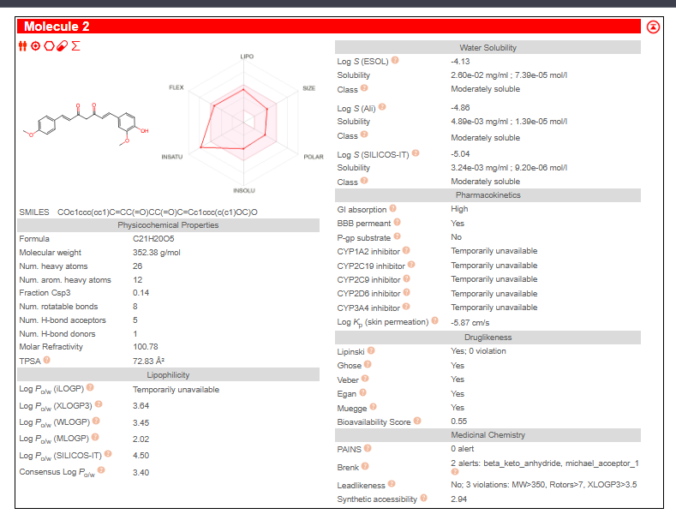
Toxicity analysis:
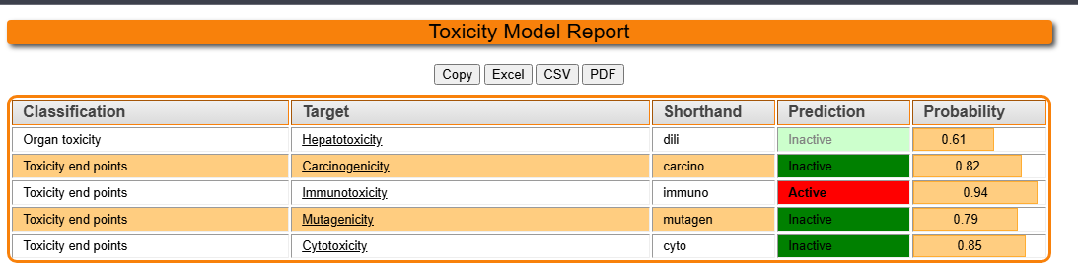

Bisdemethoxycurcumin
- Excellent ADME profile, Better aqueous solubility than Curcumin, Suitable for docking.
THE ADME ANALYSIS and TOXICITY ANALYSIS:
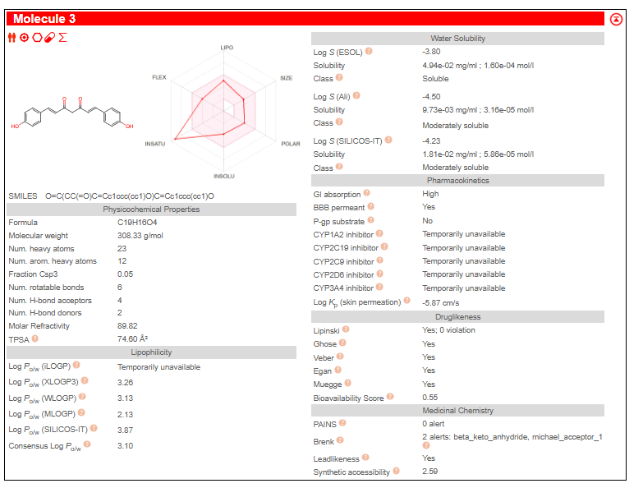
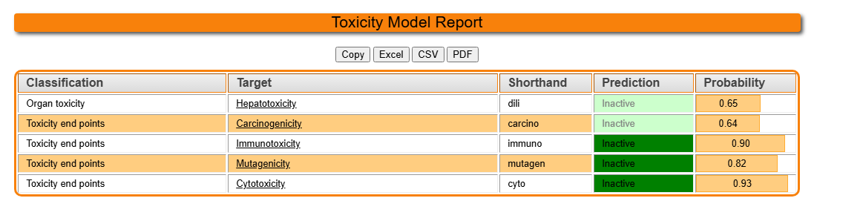
Calebin A
Calebin A was not selected for molecular docking because, although it possesses antioxidant and anticancer properties, its activity against hepatocellular carcinoma and the PI3K signaling pathway has been investigated far less extensively than that of curcumin. Additionally, there are fewer molecular docking and experimental studies validating its interaction with PI3K, making it a less suitable candidate for this study.
Cyclocurcumin
Cyclocurcumin was excluded from molecular docking because of the limited evidence supporting its anticancer activity against hepatocellular carcinoma and its relatively low number of studies targeting the PI3K pathway. Compared with curcumin and its major analogues, Cyclocurcumin has lower research validation and less documented therapeutic potential, making it a less appropriate choice for the present investigation
Docking with curcumin:
The ligand (curcumin)docked with the active site of recptor protein P1k3CA.
Key interacting residues include
TRP A:700, HIS A:665, VAL A:853, GLN A:859,
PHE A:930, ILE A:972, VAL A:950, ILE A:900,
LYS A:802, ASP A:933, ILE A:848, SER A:774,
MET A:772, ARG A:852, ASN A:853, SER A:854, and MET A:922.
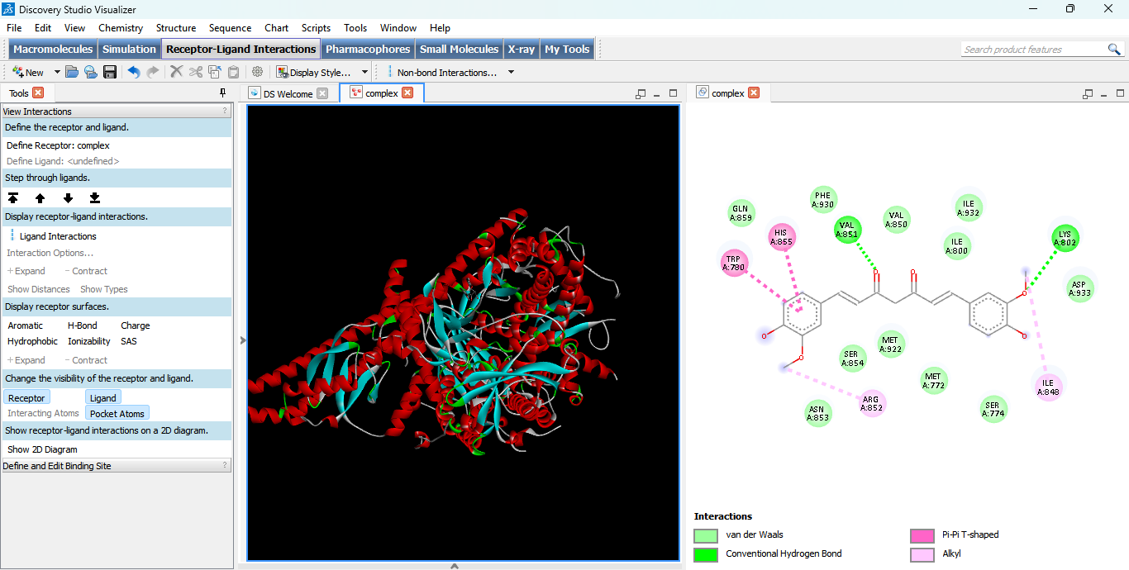
Figure 9 Molecular docking interactions between the ligand and receptor, visualized in Discovery Studio Visualizer. (Left) Overall 3D representation of the receptor-ligand complex, showing the protein secondary structure (α-helices in red, β-sheets in cyan, loops in gray/white) with the docked ligand bound within the binding pocket. (Right) 2D interaction diagram depicting the residues within the ligand-binding site and their corresponding non-bonded interactions, including van der Waals contacts (light green), conventional hydrogen bonds (dark green), Pi-Pi T-shaped interactions (magenta), and alkyl interactions (pink)
In docking result
The docked conformation with the lowest binding free energy was selected for further interaction analysis because no larger multi-member cluster with a comparable energy was observed."
table shows:
Rank | Energy | Cluster RMSD
1 | −3.72 | 0.00
2 | −3.64 | 0.00

Every row has Sub Rank = 1, which suggests each run formed its own cluster (each cluster contains only one pose).
That means there is no large cluster to compare. In this situation, the standard approach is to choose the lowest-energy conformation, which is Rank 1 (−3.72 kcal/mol).
Docked Parameter:
The binding-site center used for site-specific docking (derived from the native ligand 1LT) was
Parameter | Native binding site
X | -1.319
Y | -9.513
Z | 16.948
Docking analysis:
Molecular docking analysis revealed that Curcumin binds within the binding region of PI3Kα through a combination of hydrogen bonding, hydrophobic interactions, π–anion interactions, π–alkyl interactions, and van der Waals forces. Conventional hydrogen bonds with Lys943 and Gln1014 are expected to contribute significantly to the stability and specificity of binding. Additional stabilization is provided by hydrophobic contacts and van der Waals interactions with neighboring residues. A single unfavorable acceptor–acceptor interaction involving Gln579 was observed, which may slightly weaken the overall binding affinity. Overall, the interaction profile suggests that Curcumin is capable of occupying the binding pocket of PI3Kα, although the docking score of −3.72 kcal/mol indicates a relatively weak predicted binding affinity compared with potent PI3K inhibitors..
What can be interpreted from this 3D image?
- Curcumin is located within a cavity of the protein, not floating away from the receptor.
  - It appears to be partially buried inside the protein structure.
  - This indicates that AutoDock predicted a binding site rather than placing the ligand completely on the external surface.
- The ligand adopts an elongated conformation.
  - Curcumin's long structure fits along the shape of the binding region.
  - This orientation allows both aromatic rings and the central linker to interact with surrounding amino acid residues.
- The ligand is surrounded by protein secondary structures.
  - The ligand is positioned near several α-helices (red) and loops (white), suggesting it is enclosed by the protein rather than being solvent-exposed.

Docking with Dimethoxycurcumin:
Dimethoxycurcumin, keep everything identical to the previous dockings:
- ✅ Receptor: 4JPS
- ✅ Grid center: (-1.319, -9.513, 16.948)
- ✅ Grid size: 40 × 40 × 40
The docking analysis:
Demethoxycurcumin was successfully docked into the active site of the PI3Kα (4JPS) protein using AutoDock 4. The best docking pose showed a binding affinity of −6.22 kcal/mol,from the DLG file, indicating favorable interaction with the receptor. The selected pose (Cluster 1, Conformation 1) occupied the predefined binding pocket, suggesting that demethoxycurcumin binds at the active site of PI3Kα and may exhibit inhibitory potential comparable to other curcuminoids.
The interacting residues:

The Key interacting residues include TRP A:700, GLN A:959, HIS A:955, VAL A:850, VAL A:853, ARG A:852, ASN A:853, SER A:854, MET A:922, PHE A:930, ASP A:933, ILE A:800, ILE A:932, ILE A:848, LYS A:802, and ARG A:770.
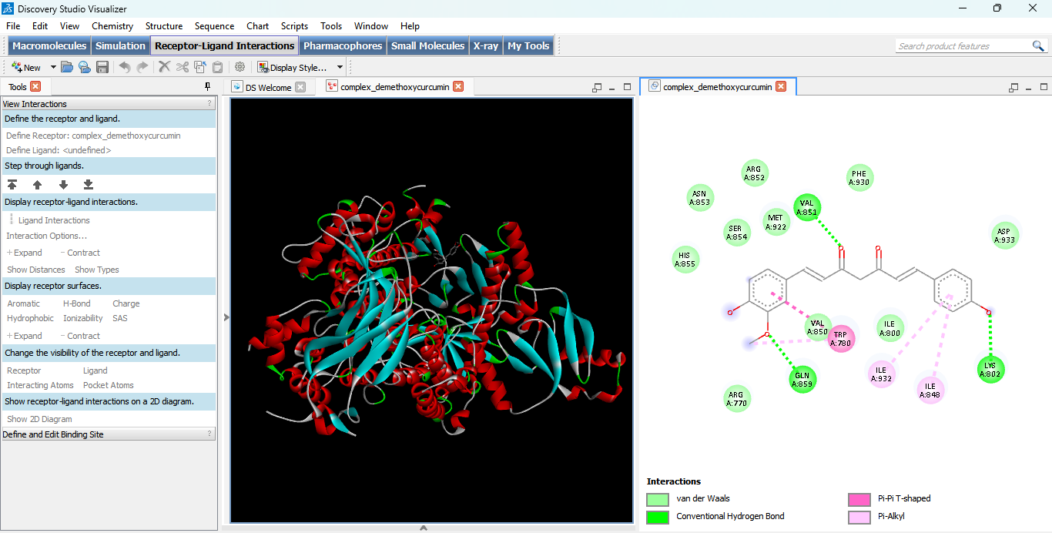
Figure 10 Molecular docking interactions between demethoxycurcumin and the receptor, visualized in Discovery Studio Visualizer. (Left) Overall 3D representation of the receptor-ligand complex, showing the protein secondary structure (α-helices in red, β-sheets in cyan, loops in gray/white) with the docked ligand bound within the binding pocket. (Right) 2D interaction diagram depicting the residues within the ligand-binding site and their corresponding non-bonded interactions, including van der Waals contacts (light green), conventional hydrogen bonds (dark green), Pi-Pi T-shaped interactions (magenta), and Pi-Alkyl interactions (pink)
Docking with Bisdimethoxycurcumin:
The interaction profile suggests that Bisdemethoxycurcumin occupies the predefined active site of PI3Kα (4JPS) and is stabilized through a combination of hydrogen bonding, hydrophobic interactions, and van der Waals contacts. The presence of a conventional hydrogen bond together with multiple hydrophobic interactions indicates favorable ligand–protein binding, supporting the potential of Bisdemethoxycurcumin as a candidate inhibitor for PI3Kα
Bisdemethoxycurcumin, keep everything identical to the previous dockings:
- ✅ Receptor: 4JPS
- ✅ Grid center: (-1.319, -9.513, 16.948)
- ✅ Grid size: 40 × 40 × 40
Docking analysis :
The molecular docking results demonstrated that Bisdemethoxycurcumin binds effectively within the active site of the PI3Kα (4JPS) receptor, with a lowest binding energy of −6.11 kcal/mol, indicating favorable binding affinity and a stable protein–ligand complex. The interaction was stabilized by a conventional hydrogen bond, π–sigma, π–alkyl, π–sulfur, and multiple van der Waals interactions involving key active-site residues. The observed binding pattern confirms that Bisdemethoxycurcumin occupies the same catalytic binding pocket targeted during site-specific docking and suggests its potential as a promising natural PI3Kα inhibitor. When considered alongside Curcumin and Demethoxycurcumin, these results support the therapeutic potential of turmeric-derived curcuminoids for the inhibition of PI3Kα in hepatocellular carcinoma and provide a strong basis for further experimental validation.
The interacting residues :
Key interacting residues include ASP A:933, LYS A:802, ILE A:932, ILE A:848, PHE A:930, VAL A:851, ILE A:800, MET A:772, MET A:922, VAL A:850, TYR A:836, TRP A:780, GLU A:849, LEU A:807, SER A:774, and SER A:854.
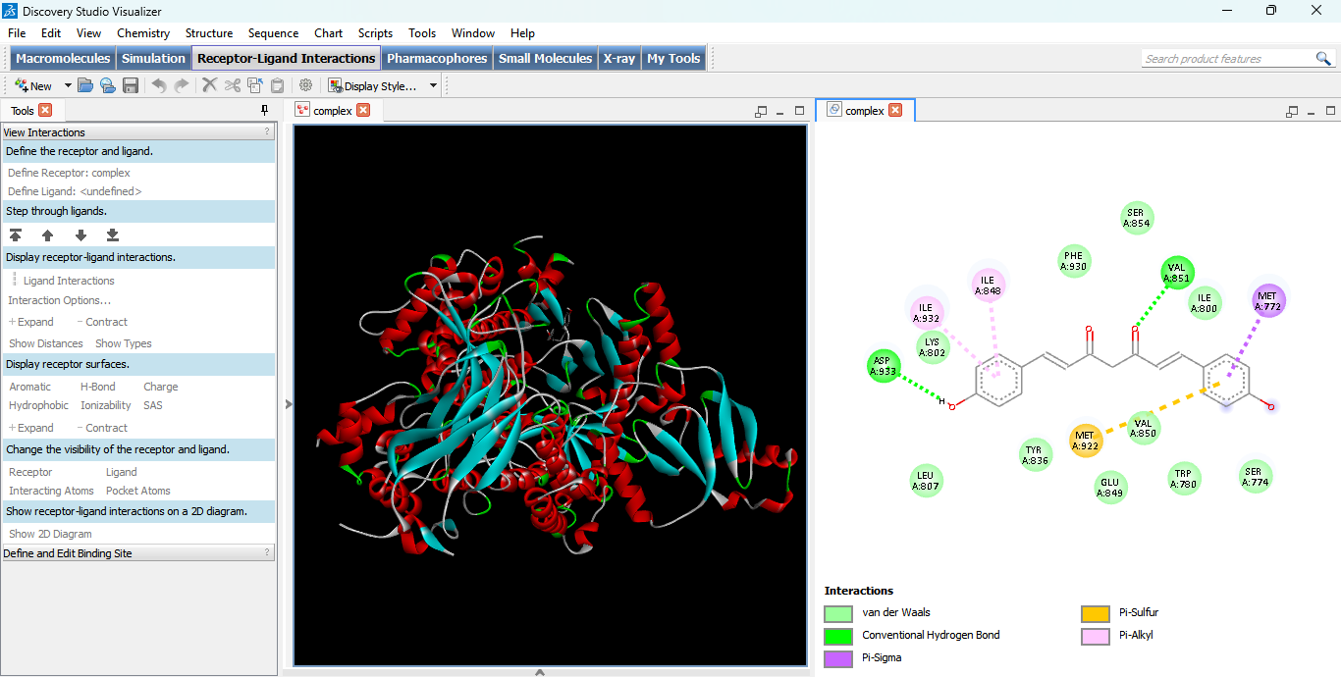
Figure 11 Molecular docking interactions between bisdemethoxycurcumin and the receptor, visualized in Discovery Studio Visualizer. (Left) Overall 3D representation of the receptor-ligand complex, showing the protein secondary structure (α-helices in red, β-sheets in cyan, loops in gray/white) with the docked ligand bound within the binding pocket. (Right) 2D interaction diagram depicting the residues within the ligand-binding site and their corresponding non-bonded interactions, including van der Waals contacts (light green), conventional hydrogen bonds (dark green), Pi-Sigma interactions (purple), Pi-Sulfur interactions (orange), and Pi-Alkyl interactions (pink)

